Internal Function - Unit Testing

**uint64_t get_nft_number_from_name(name userid); -- version 10a (2023-09-30)**

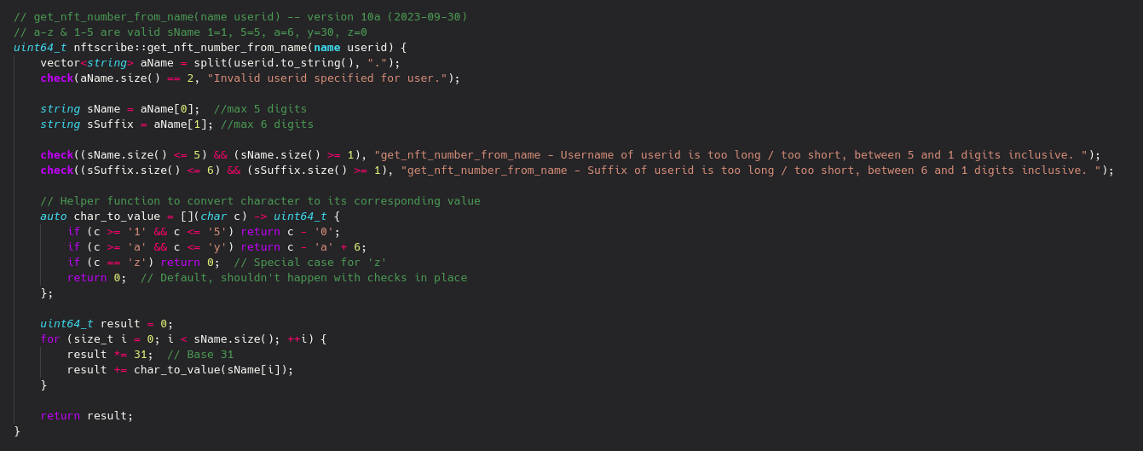

Testing the z.suffix to yyyyy.suffix breadth of base 31 NFT # possibilities.  
  
**PASSED** Max Test (yyyyy.nft)

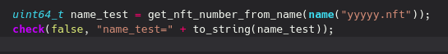

Result Matches (31^5) - 1

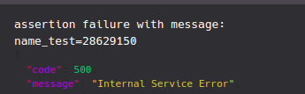

**PASSED** Min Test (z.nft)



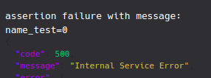

Result Matches 0

**PASSED** Threshold Test (yy.nft) to (1zz.nft) Requires no overlap of value

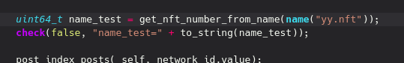

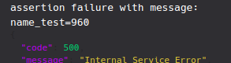

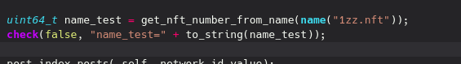

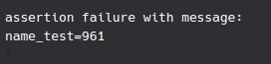

Result was correctly increased by 1 in value.

**PASSED** Boundary Tests - All Should Fail (.nft), (yyyyyy.nft), (aa.nft.vi), (test)

(.nft) - correct



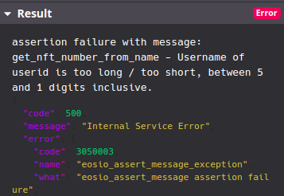

(yyyyyy.nft) - correct

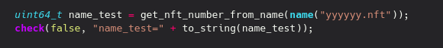

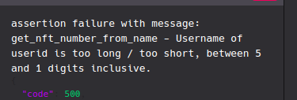

(aa.nft.vi) - correct

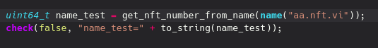

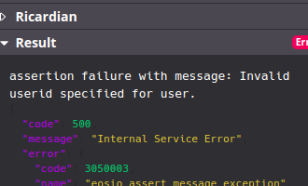

(test) - correct



